“Ant Colony Optimization and Networking”

Mohammed Mahdi Salih Altufaili,
Assistant Lecturer, University College of Humanity Studies - Computer

Abstract
The overall performance of any network control system heavily depends on the routing of its networks. Determining the best route forms the routing problem and it has to maximize the lifetime of its performance in the routing protocol (Blum, 2004). It involves the calculation, choosing and assigning a relevant path that will ensure data is transferred efficiently from one source to another (Vijayalakshmi, Francis, and Dinakaran, 2015). Finding the shortest path with maximum performance is often a problem, but can be easily solved by modelling the network in algorithms. This paper addresses the routing problem addressing the shortest path routing technique by use of Ant Colony Optimization algorithms.
Index Terms: Shortest path routing technique, ant colony optimization.

Ant Colony Optimization
Ant Colony Optimization (ACO) is a modelling technique that makes use of algorithms in presenting the behavior of ants in finding the shortest path to take in getting food. Ants deposit pheromone on the path used while searching for food, from the nest to the food (Pizzo, 2015). The pheromone acts as a guideline while returning from the food search, and ants covering the shortest distance have more pheromone compared to those that covered a longer distance (Demazeau, 2010). This is because pheromone evaporates after a certain amount of time and rate, therefore only paths that have been frequently visited remain viable over time. By the use of the pheromone, the other ants end up using the path.
In Ant Colony Optimization, artificial ants are used to mimic data packets and build solutions considered optimal for the communication system. The packets are simulated from the source to the desired destination, with the forward artificial ants selecting the next node randomly for the first time, based on information received from routing table (Dorigo, 2006). On reaching their destination, the ants update the routing table by updating their pheromone deposit based on the total path travelled. By using feedback data left by the forward ants, other ants can choose the shorted path to a destination (Solnon, 2010).
The probability of the ant picking the path is determined by the nodes made by the forward ants. If the density of the nodes is high on a certain route, the shortest path will be picked, but if the density of the nodes is low it will be dropped. The probability of the forward packet dropping is given by
T=e−c.D
P(drop)=1−T1+T (Ostfeld,2011)
The picking up probability is given by
T=e−c.D
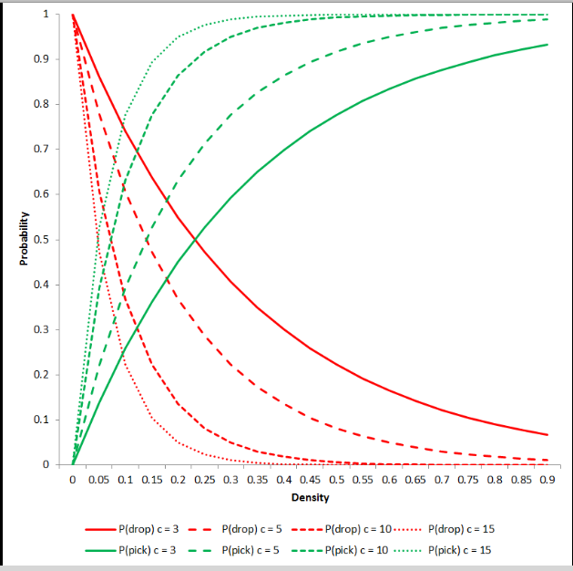
P(pick)=1−1−T1+T=1−P(drop)

Figure 1, Density-probability relationship

On simulating the probability, it is evident that the choice of nodes is based on the number of forward packets, m, and the number of nodes on its path, s. The m packets are located uniformly on the grid at first, then take a path along the xy coordinate, with a two dimensional vector of s (Ostfeld,2011). The final coordinate is represented by the height, h and the width w. on the grid in locating the location on the grid. Since there are no edges on the grid, it wraps round and, therefore, it reduces the maximum distance between any two paths to max (12h, 12w). This leaves a grid without edges, essentially the route where the paths will be located (Ostfeld, 2011)

This can further be modelled by showing the average number of nodes that will be avoided in a network on implementing ACO and improved ant colony optimization IACO as shown by Zhao, Luo, and Zhang (2010).

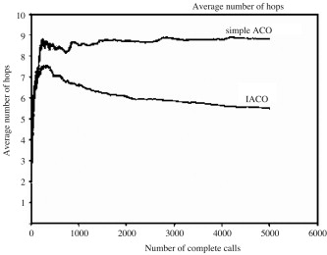

F

Figure 2, Simple- Improved ACO

On simulating the algorithm based on network systems, the average number of hops in the ACO system will reduce about 1.5 nodes for the first 500 calls (Zhao, Luo, and Zhang, 2010).
The best paths are a biased choice and will reinforce an optimal route, which improves an ordinary network by almost 3.5 hops (Zhao, Luo, and Zhang, 2010). By eliminating loops with unnecessary nodes, the network performance is hugely improved as shown by the graph below: (Zhao, Luo, and Zhang, 2010).
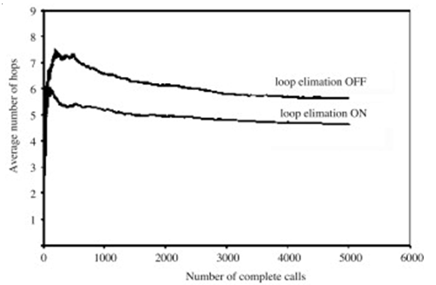

Figure 3, Loop eliminating

Conclusion
Ant Colony Optimization in networks thereby improves networks by eliminating unnecessary nodes and finding the shortest paths within a route in the network system. By use of forward packets and backward packets, loop elimination is invoked on the network leading to self-reinforcing loops that form the shortest paths thereby improving network performance.
Acknowledgement
I want to thank my parents for their endless support and encouragement, and my wife as well. This paper is dedicated to my son Yasser.

References
[1] Blum, C. (2004). “Theoretical and practical aspects of ant colony optimization” Berlin: Akademische Verlagsfesellschaft.
[2] Blum, C. (2005). “Ant colony optimization: Introduction and recent trends”, Physics of Life Reviews, 2(4), pp.353-373.
[3] Czarnowski, I., JeÌ¨drzejowicz, P. and Kacprzyk, J. (2013). “Agent-based optimization”, Berlin: Springer.
[4] Demazeau, Y. (2010). “Advances in practical applications of agents and multiagent systems”, Berlin: Springer.
[5] Dorigo, M. (2006). “Ant colony optimization and swarm intelligence”, Berlin: Springer.
[6] Mohajerani, A. and Gharavian, D. (2015). “An ant colony optimization based routing algorithm for extending network lifetime in wireless sensor networks”, Wireless Netw.
[7] Mukherjee, D. and Acharyya, S. (2010). “Ant Colony Optimization Technique Applied in Network Routing Problem”, International Journal of Computer Applications, 1(15), pp.74-81.
[8] Ostfeld, A. (2011). “Ant colony optimization”, Rijeka, Croatia: Intech.
[9] Pizzo, J. (2015). “Ant colony optimization”, [S.l.]: Clanrye Intl.
[10] Solnon, C. (2010). “Ant colony optimization and constraint programming”, London: ISTE.
[11] Vijayalakshmi, P., Francis, S. and Abraham Dinakaran, J. (2015). “A robust energy efficient ant colony optimization routing algorithm for multi-hop ad hoc networks in MANETs”, Wireless Netw.
[12] Zhao, D., Luo, L. and Zhang, K. (2010). “An improved ant colony optimization for the communication network routing problem”, Mathematical and Computer Modelling, 52(11-12), pp.1976-198

